Assignment 45.
- Practice both upload to AL11 and download form AL11?
- Download:
- Create a structure
- Lv_file for directory to create a file in /tmp directory.
- Lv_data for store data from lv_file.
- Fetch data using select query.
- For download use OUTPUT in DATASET.
- Merge all field data using concatenate SEPARATED by ‘#‘(any symbol). For proper alignment.
- 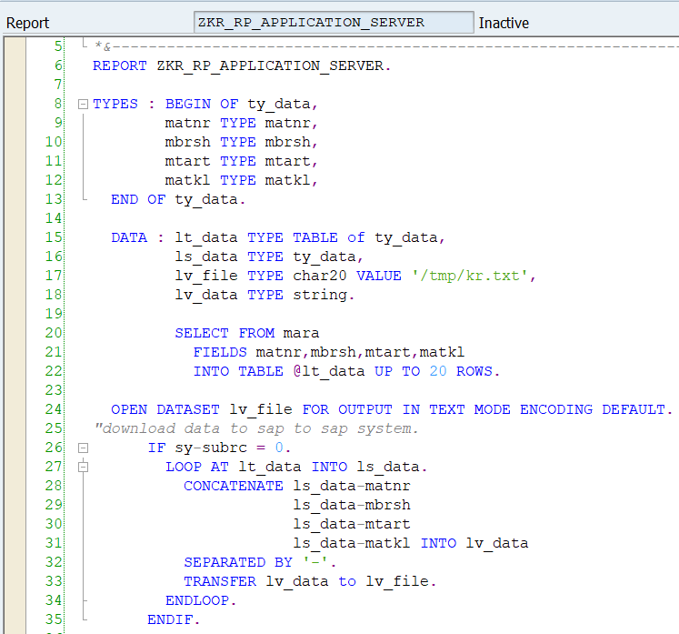
- To get the downloaded file in sap system we need to navigate to the AL11 tcode and search for /tmp directory -> double click on that and search the created -> double click on created file(kr.txt) and view data.
- 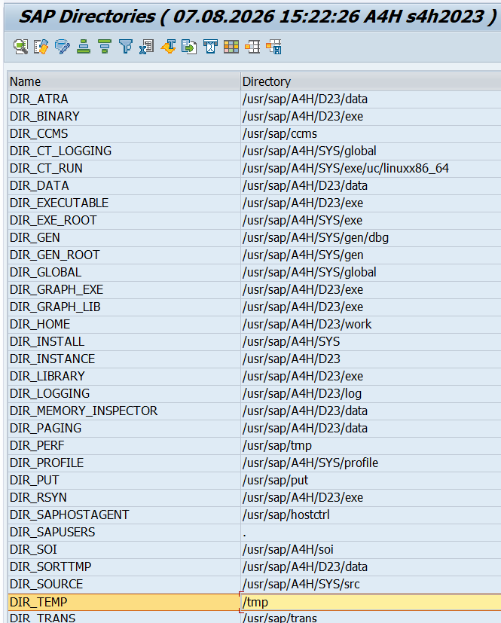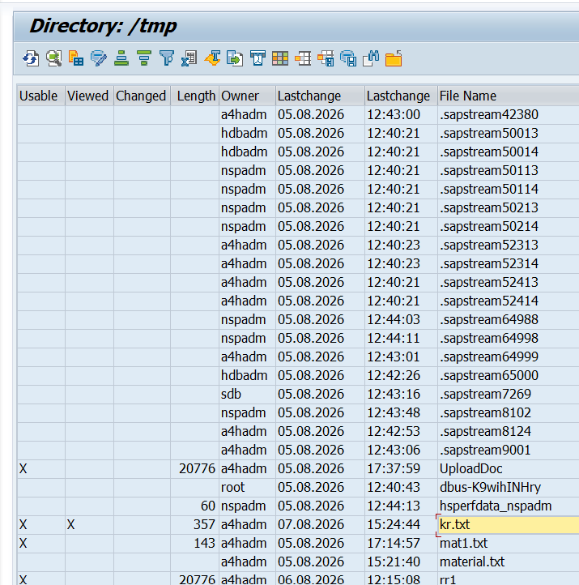
- 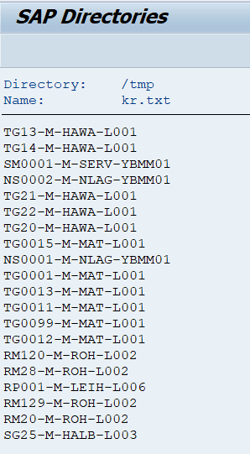
- Upload:
- 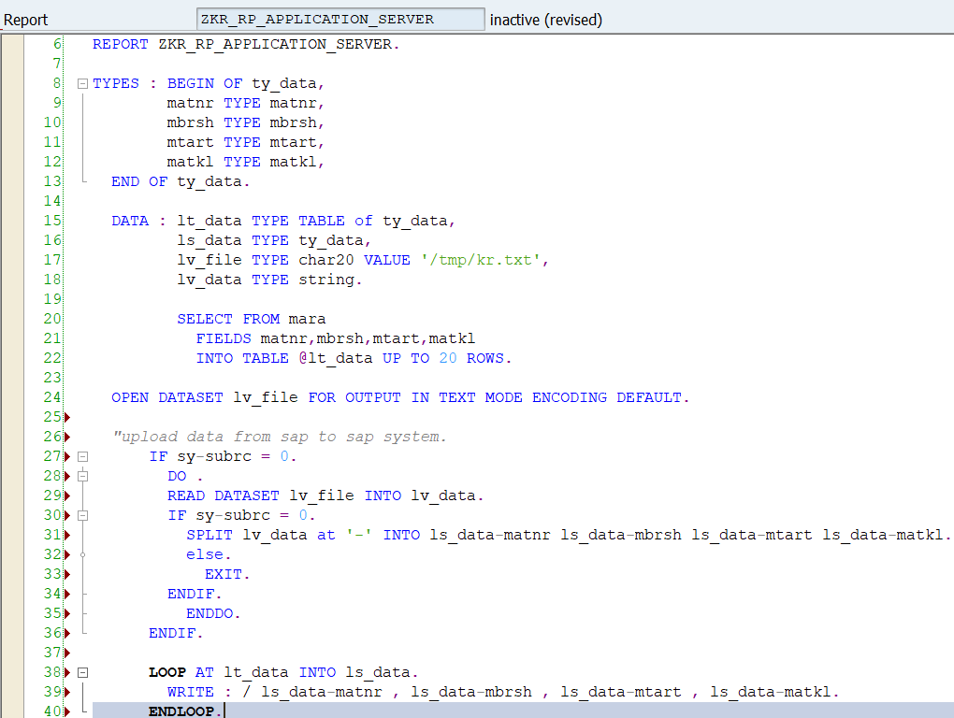
- To delete dataset:
- 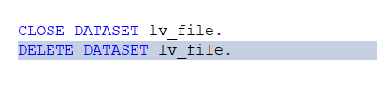

- Upload the data from legacy system to SAP system TO ztable( take 2 to 3 fields)?
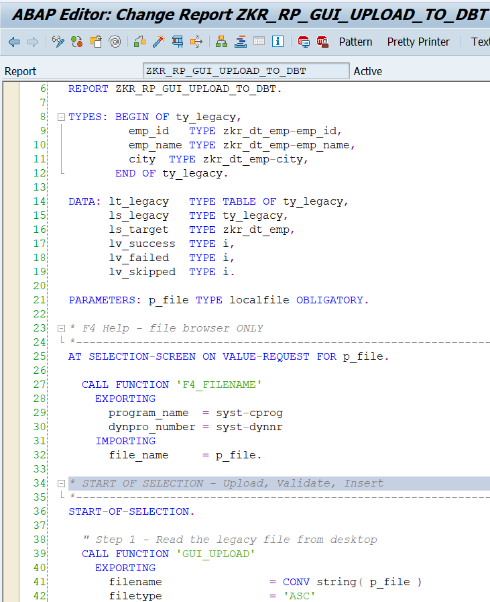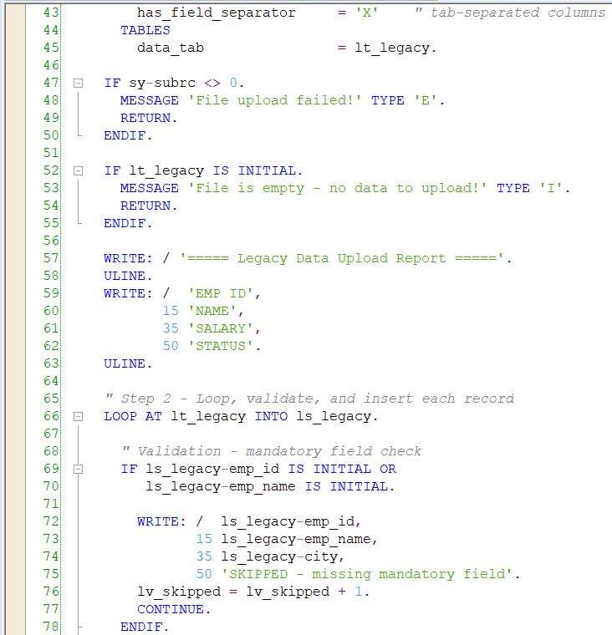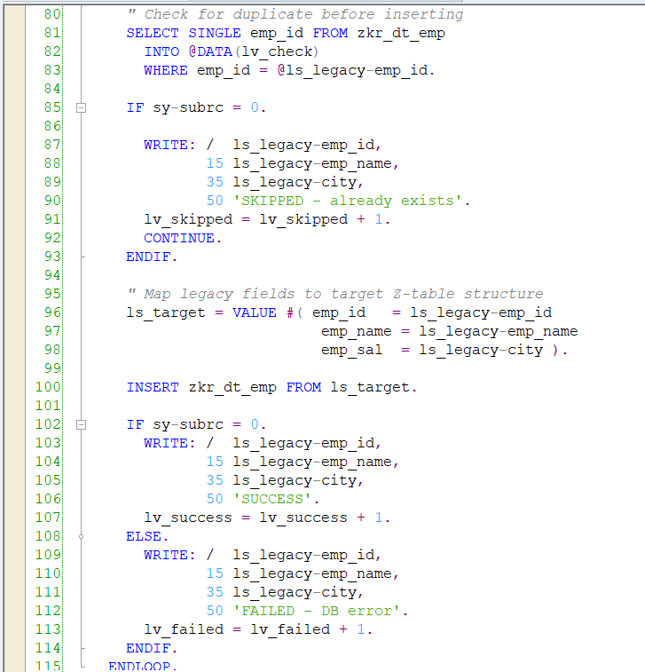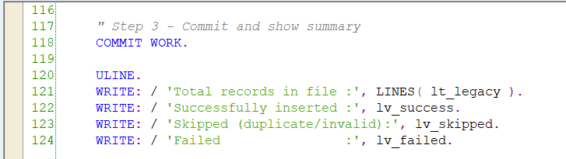

- Output:
